Dataflow:

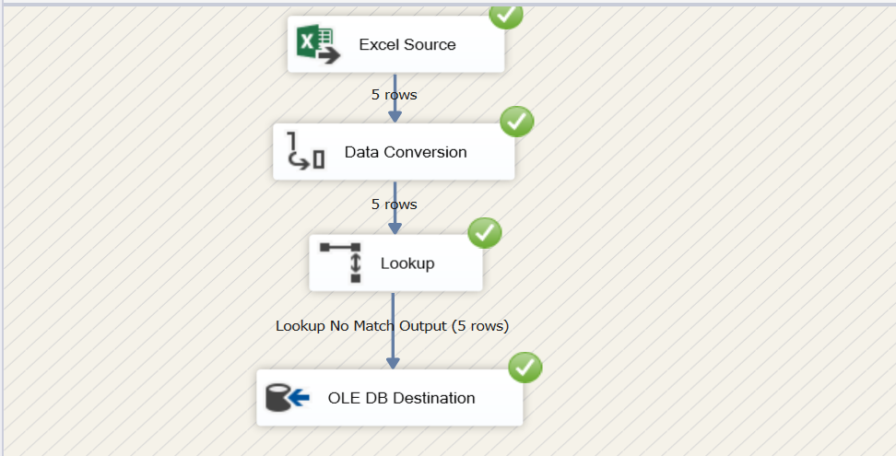

Source:

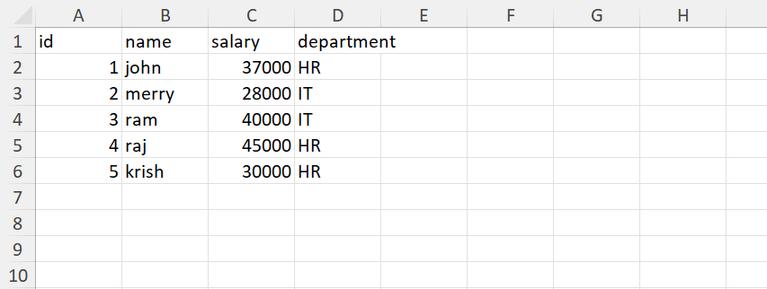

Destination:

After updating:

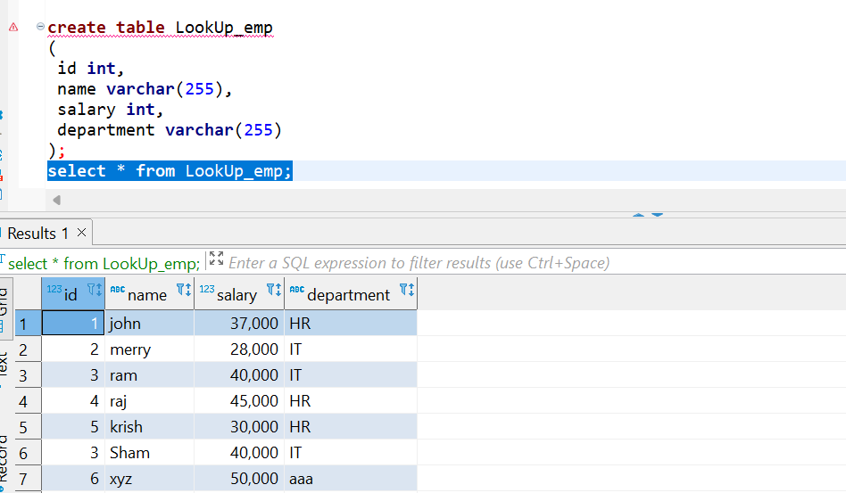

1. Dataflow:

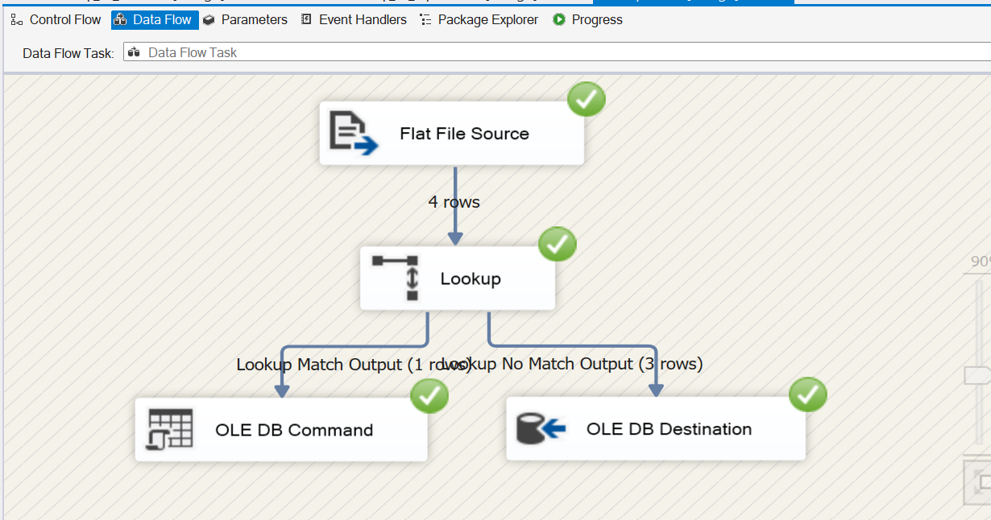

Source:

Destination:

Destination after ole db update:

